Installing IBM’s Access Client Solutions

This is a Java based application. Please visit: https://java.com/en/ to download the newest version.

Right click the “Windows start button” and select “File Explorer”.
Create a new folder under the C Drive called “ACS”.

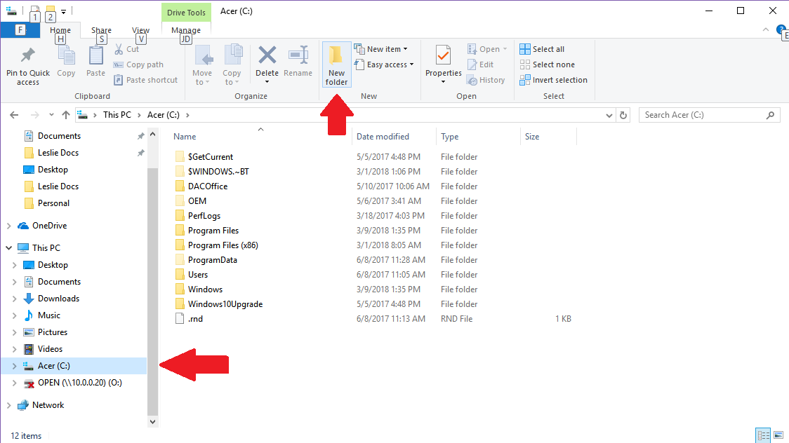

Minimize this folder and locate the “IBMiAccess_v1r1.zip” file.
Right click the file and select “Extract all”.
Select browse and enter the new ACS folder: C:\ACS
Leave the box checked to “Show extracted files when complete”.
The extracted files should now appear in the ACS folder.

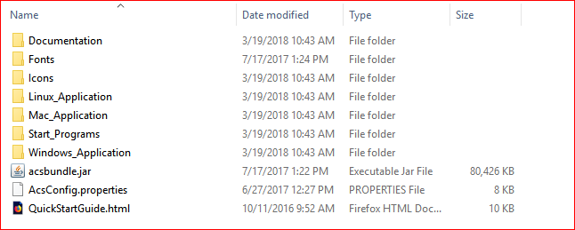

Open the folder called “Windows_Application” and double click “install_acs_64_allusers.js”

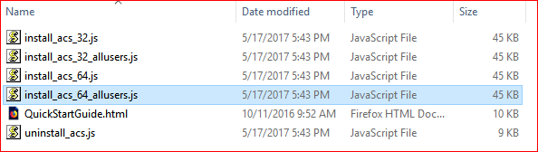

Several things will begin flashing across the screen as the utility performs the installation.
You may receive a Windows Security warning about installing the software. Take options to allow the installation.
You will be prompted with a series of dialog boxes. Answer YES to them all.

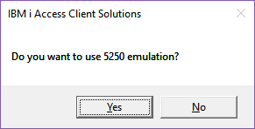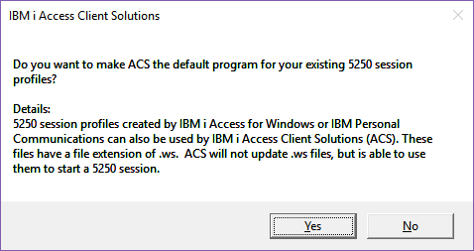
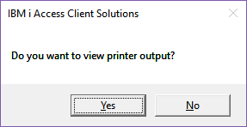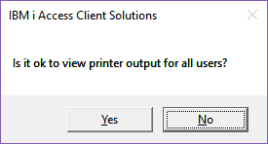
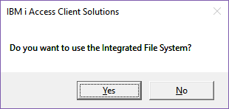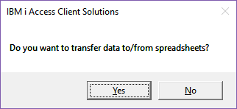
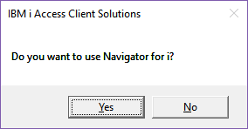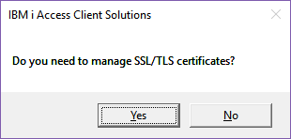
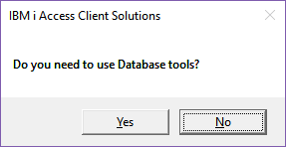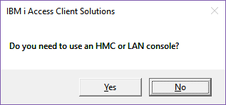
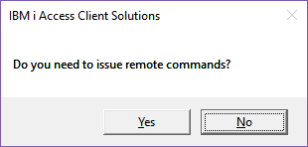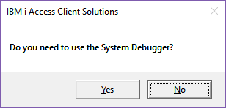
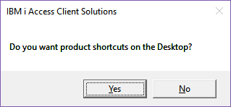

More items should flash across the screen. Once it has completed you should see this dialog box:

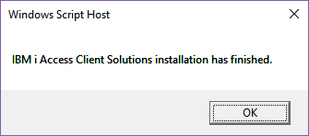

You will have two new icons on the desktop:

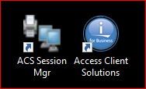

Open the ACS Session Manager.

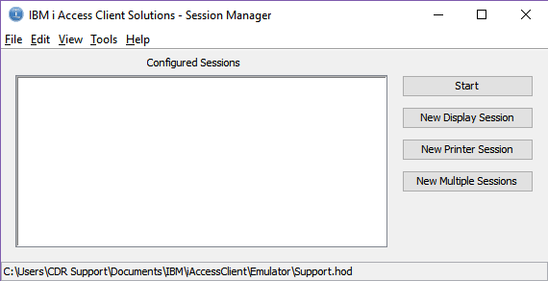

Choose “New Display Session”

Fill out the following sections:
- Session Name – An applicable name to call the session. Usually named DAC
- Destination Address – Substitute your AS400’s IP address for “xxx.xxx.xxx.xxx”
- Destination Port – The default port is 23. If you’re unsure of your port number contact your Networking Administrator.

Select 27x132 for the Screen Size
Then click “OK”.
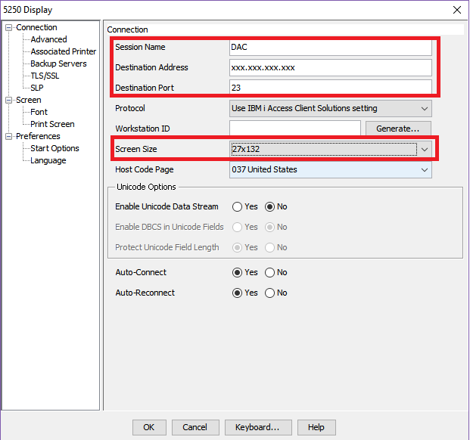

In the IBM I Access Client Solutions – Session Manager you should see an icon called DAC. You can right click it and send it to the desktop as a shortcut.

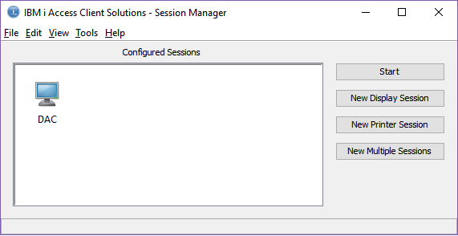

Double click the DAC session on your desktop and sign in with your credentials.

